Santa Maria Valley Tourism Marketing District (SMV TMD)
Advisory Committee Minutes
May 17, 2022
12:30 Holiday Inn
DRAFT UNTIL APPROVED
Advisory Committee: Max Tucker, Ryan Swack, Cherag Patel, JP Patel, Ketan Panchal, Jerry Patel
City Staff: Mark van de Kamp
Chamber|Staff: Jenn Harrison, Glenn Morris, Cheryl Cuming, Emily Kitts
Guests: Richardo Herrera
KPS3 | Team: Rob, Brittany, Sara, Nicole

Call to Order by Max at 12:31pm
Roll call – Seth is absent. All others present.

Public Comment:

Consent Calendar:
Minutes: Motion to accept: JP, 2nd Cherag. All in favor. Motion carries.

Financials: Jerry asked if events fund of $10,000 will be rolled in reserves and Glenn confirmed. Motion to accept: Cherag, 2nd Ketan. All in favor. Motion carries.

Cheryl noted that both the TOT and STR reports were included in the packet. TOT is 30% above last year, and STR should occupancy at 11%, ADR at 22% and RevPAR at 36%.

Presentation: None

Business Items
Discussion & Action Items:
21 |22 Year-End and 22 | 23 budget:
Glenn provided details FY22 Budget Adjustments: One-Time Surplus Funds including:
- Public Art sponsorship
- Welcome Banners
- Event & Festivals Strategy
- Visitor location data
- Beat Inflation Vacation seasonal campaign
- In-market visitor program

Cherag asked about Opportunity funds, and Glenn noted that the unallocated balance of $53,000 would be added to the Opportunity Reserve/Future event sponsorship, growing the fund to almost $90,000 coming into FY 22|23.

Advisory Committee talked in detail about each of the programs, including:
- Possibility of banner sponsorship
- Increased local visibility about tourism efforts
- Sharing data so City better understands the impact that lodging and tourism district has made. Mark noted tourism is in the top 4 sources and TOT makes up $4 million of almost $200 million, sharing that 62% of the general fund budget supports public services.
- Focus on additional collaboration with the City and future events
- Additional interaction with the airport

Advisory Committee reviewed which programs they are interested in supporting:
- Welcome Banners ($16,000) – motion by Jerry; 2nd by Ryan. All in Favor. Motion Carries.
- Event & Festivals Strategy ($20,000) – motion by Ryan; 2nd by JP. All in Favor. Motion Carries.
- Visitor location data ($5,800) – motion by JP; 2nd by Cherag. All in Favor. Motion Carries.
- In-market visitor program ($40,000) – discussion that additional legwork needed to explore the options. – motion by JP; 2nd by Cherag. All in Favor. Motion carries.
- Beat Inflation Vacation seasonal campaign ($40,000) – Brittany presented details based on using TripAdvisor average costs for hotel, wine tasting and dining. Discussion around market focus and campaign timing. Motion was made by JP; 2nd by Ryan. Majority in Favor with no vote from Cherag and Ketan. Motion carries.
- Public Art sponsorship ($10,000) – wants to see collaboration with City on shared funding; noted City funding is provided at $40,000 - $50,000 through public art grants and some private funding. AC asked that SM Rec & Parks to provide a presentation. AC discussed their interest in funding infrastructure projects, and the difference between this and beautification. Motion was made by JP; 2nd by Ketan. All in Favor. Motion carries.

Arts Committee appointees:
Request to include lodging partners on the Santa Maria Rec & Parks Public Arts Committee has been confirmed. Motion made by Cherag; 2nd by JP to appoint Ricardo Herrera and Jerry Patel. All in favor. Motion carries.
22 | 23 Budget:
Glenn share details for projected 22 | 23 budget totaling $764,500, and Rob/Brittany provided marketing details. Jerry asked about local event investment, and Glenn confirmed $85,000 coming into 22 | 23 thru the Opportunity Fund. Ketan asked about funding for events that hotels have. Cherag asked about administrative, and Glenn provided details. Motion made by Cherag; 2nd by Jerry to approve the 22 |23 budget as presented. All in favor. Motion carries.

22 | 23 Marketing Plan:
Rob and Brittany provided an overview of the SMV marketing approach reviewed at the April 7th meeting, and Cheryl noted the final plan was included in packet. Motion made by JP; 2nd by Ryan to approve the marketing plan as presented. All in favor. Motion carries.

Strategic Planning Pathways:
Cheryl reviewed the proposed strategic planning pathways, noting that with the AC’s approval that the Events & Festivals Strategy work will begin.
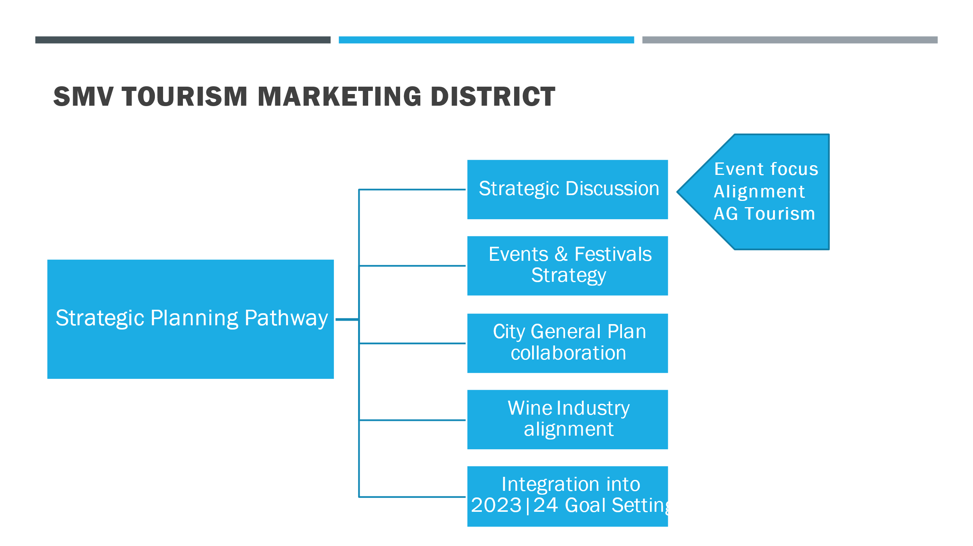

Information Items:
KPS3 presented marketing report including:
- Website & Marketing performance: acknowledged that organic traffic is up 34% YoY and 557 hotel referrals were provided in April.
- Email redesign: shared updated look for Fav 5, bi-weekly and drip campaign emails.
- Recent Blogs: purposed content from recent PR articles and Visitor Guide content.
- BBQ Month: Nicole noted success with PR with our 2 million views on the A|P.
- Beat Inflation Vacation: based on AC’s approval, the campaign will be launched immediately.
- New welcome banners: Design concepts shared and based on AC’s approval of the funding, this project is approved for a July launch.
- What’s Next/Upcoming initiatives:
  - FY 23 marketing plan
  - Email template redesign
  - Multi-generational trip planning strategy
  - Grow influencer program
  - FAMs for niche markets like motorcycles and foodies
    - RoadRunner, SD Foodie and Jared Ranahan
  - BBQ Month, Rodeo and other local events

Updates:
VCB/TMD:
Jenn noted launch of the Wine Trolley, and shared her insights from the Hot Air Balloon Festival she and Erin attended in June.

Committee Member Reports:

Future Agenda Item
- City of Santa Maria Recreational & Parks presentation
- 22 | 23 Bureau focus
- City General Plan – what do hotels want to see?

Adjourn at 2:20pm

Next meeting: July 28, 2022 at 12:30pm

